Input to Tank 1 Input to Tank 2

TANK-2

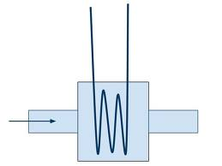

Heater

TANK-1

L1

L1

**GSM Module**

Motor operated

L2

L1

Pump

**Temp. display module**

**Temperature Sensor Module**

L2

L1

**Heater Controller module**

Manual Valve 1 Manual Valve 2

**LEVEL CONTROL MODULE**

**GSM MODULE**

**Level control Module**

**(L1,L2,L3,L4,L5,L6)**

**Level display module for tank-1 and tank-2.**

**Note: Monitoring of the whole process is to done on mat lab. (Level and temperature)**